**Installation and configuration of Rustdesk on a PC at a Petrol Station**

**Installation**

1. Connect to the PC at the petrol station via Anydesk
2. Go to any browser (Chrome, Edge or Firefox) and search Rust Desk Download>>>Click on the link and click Download
3. Click on the Windows (64- bit) EXE version and the download will start

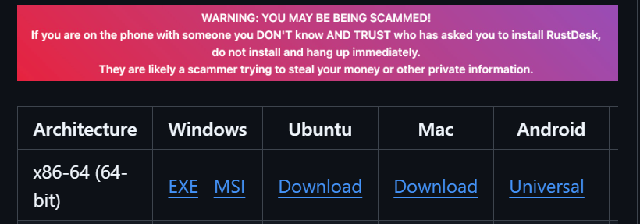

1. Click on the download file location
2. Pin the Rustdesk icon to taskbar

**Configuration**

1. Open the Rustdesk application and head to the upper left corner of the screen

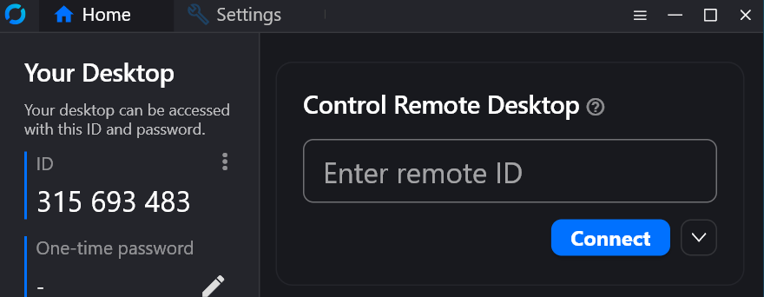

1. On the ID panel, head to the 3 dots on the right and click

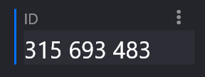

1. This will take you to the Settings section located on the left of the screen.

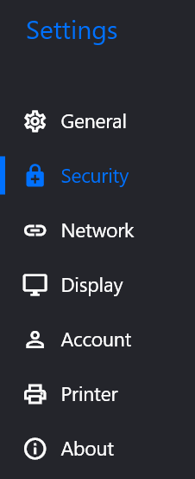

1. Scroll down on the settings and click on Network >>> Click on Unlock network settings

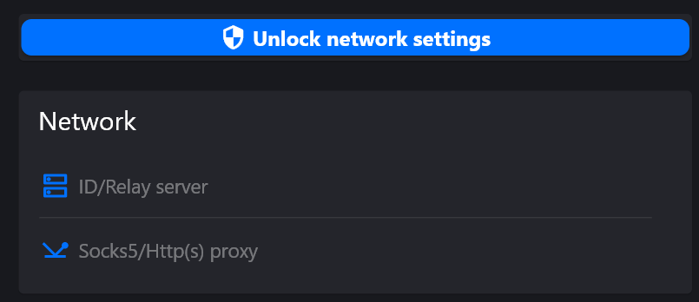

1. A pop - up will appear asking whether you want to allow this app to make changes to your devices>> Click Yes
2. Click on ID/Relay server

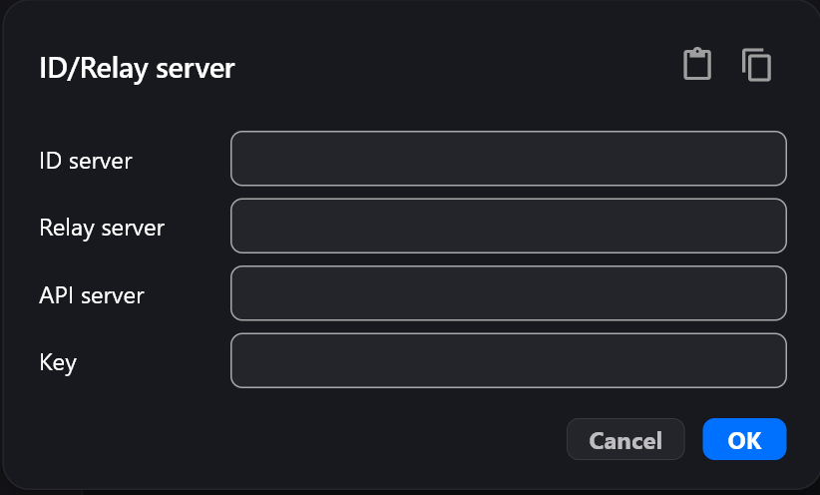

1. In the ID server and Relay server section, enter 20.172.38.162
2. In the Key section, enter DHYd86tRljqMJyZFlkvQ72q8iuNOpXfgtwNZ5qMmeEI=
3. Click Ok
4. Scroll down the settings and click on Display
5. Set the Default view style as Scale adaptive

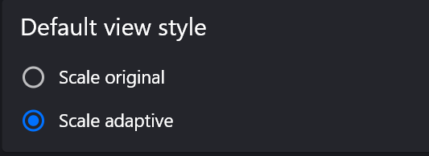

1. Set Default image quality as Good Image quality

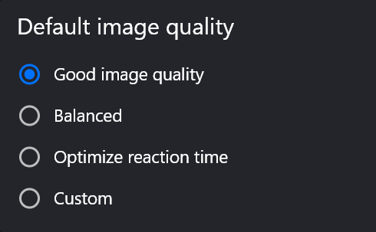

1. Scroll up the settings and click on Security >>> Click on Unlock security settings



1. A pop - up will appear asking whether you want to allow this app to make changes to your devices>> Click Yes
2. Scroll to the password section

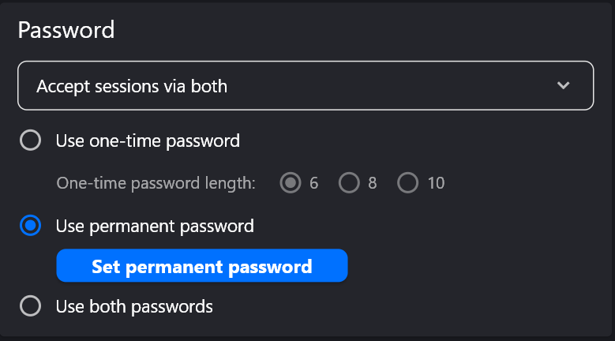

1. Click on use permanent password >>> Click the Set permanent password button

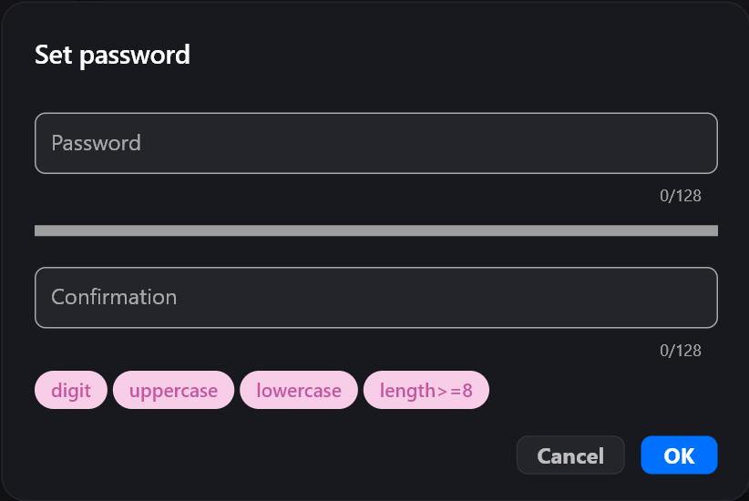

1. Enter Admin@123 as the password and confirm it
2. Click Ok >>> Head back to home
3. Test out the Rustdesk on the PC by closing the Rustdesk window and the Anydesk session.
4. Ask the station manager to open the Rustdesk app and enter the Remote ID and click Connect.